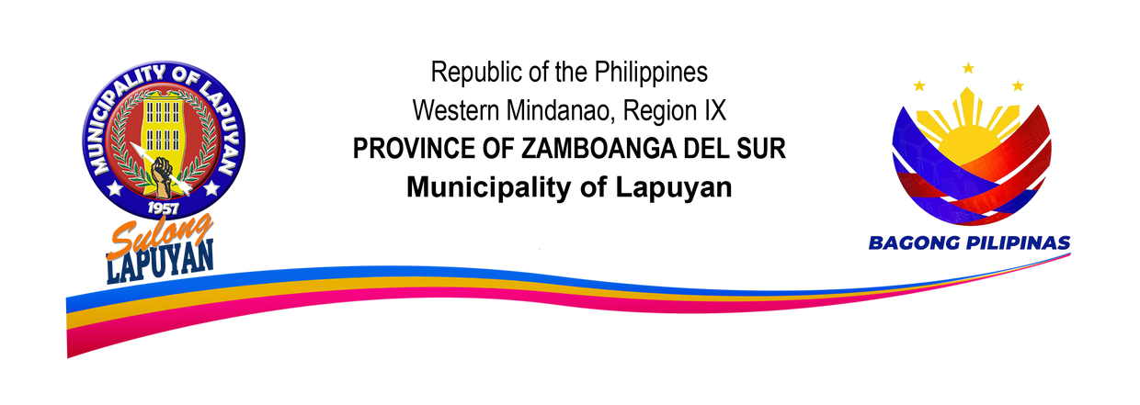

**TOURISM CULTURE AND THE ARTS OFFICE**

**CITIZEN CHARTER**

**Lapuyan Tourism Culture and the Arts Office ( LTCAO )**

1. **MANDATE**

**The Municipal Tourism is a division of the office of the Mayor whose mandate is to”…. Provide leadership in matters concerning local Tourism culture and the Arts, in so far as they aid the socio- economic development of the Municipality of Lapuyan”.**

1. **MISSION**

**TO PROMOTE CULTURAL AWARENESS IN ARTS AND TOURISM THROUGH COMMUNITY INVOLVEMENT TOWARDS ACHIEVING GENUINE AND SUSTAINABLE DEVELOPMENT IN PURSUIT OF THIS, WE WILL PROVIDE THE DIRECTION, SUPPORT AND IMPETUS IN MOBILIZING AND UTILIZING AVAILABLE RESOURCES BY PROVIDING THE YOUTH ALL POSSIBLE TRAININGS AND VENUES FOR CULTURAL AND ARTS PROGRAM.**

1. **VISSION**

**A UNITED LAPUYANON’S THROUGH CULTURE AND ARTS PRESERVATION AND TOURISM PROMOTION.**

1. **GOAL**

**TO IDENTIFY, DEVELOP, ENHANCE AND PROMOTE TOURISM POTENTIALS, CULTURE AND ARTS OF LAPUYAN, ZAMBOANGA DEL SUR.**

1. **SERVICE PLEDGE**

**ITS MAIN FUNCTIONS ARE THE FOLLOWING**

1. **To extend assistance to local and foreign tourist through organize socials and cultural affairs.**
2. **Provide sincere and honest service to all clientele regardless of age, gender, nationality as well as cultural and religious**

**orientation**

1. **Render utmost care, urgency and propriety in addressing the needs of individual and group that seek assistance.**
2. **Maintain decent and upright practices that demonstrate the qualities and ethical standards of good public service.**
3. **Coordinates with line agencies, civic organization and local citizens in undertaking tourism/cultural programs and activities in the municipality.**
4. **Establish linkages with the tourism advocates, as well private- public partnership or project arrangement.**